LCP Quick Start Guide

Connect Battery Power
- Within 3 hours of deployment.
- Open the power and comms port by removing the stainless steel plug fitting. Be careful and make sue to put a wrench on both the stainless steel plug and the PVC fitting to avoid twisting up the wires.
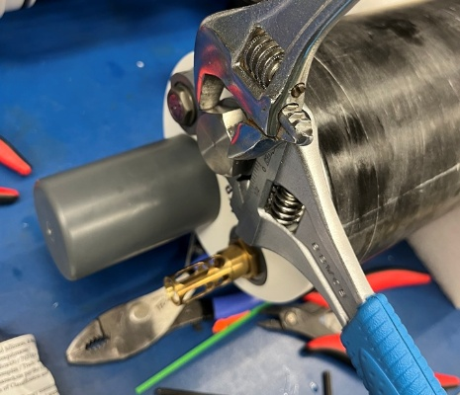
- Using supplied needle nose fliers, on the 3-D printed part’s tab, pull the coms and power cartridge out of the port fitting. It will pull out only a few inches, see pic. DO NOT pull it out further than shown as this will put strain on the wires.
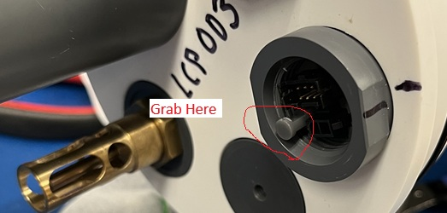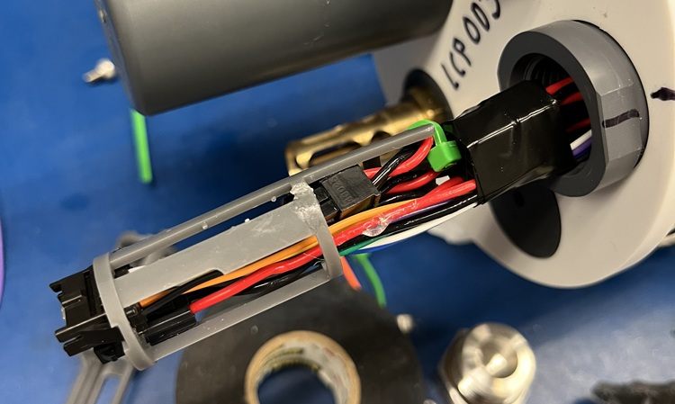
- Unwrap the black tape holding the battery power cable.
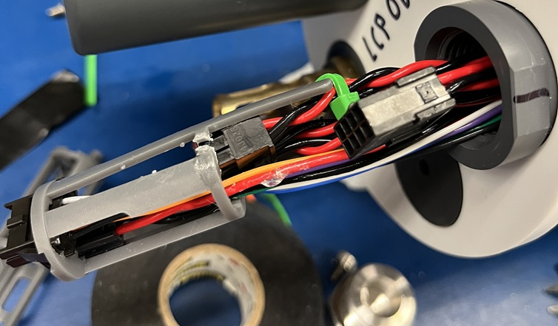
- Snip the green ziptie on the electronics power connector and pull clear of the cartridge.
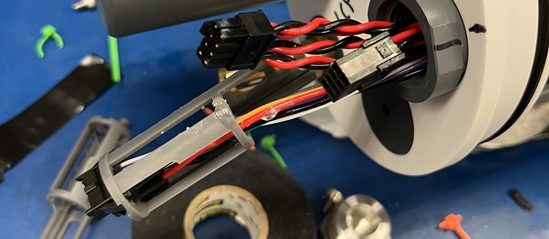
- Install the comms cable on the LCP’s comm port.
- Make sure the reset switch is set to on (this will prevent the LCP from starting up as soon as you connect power).
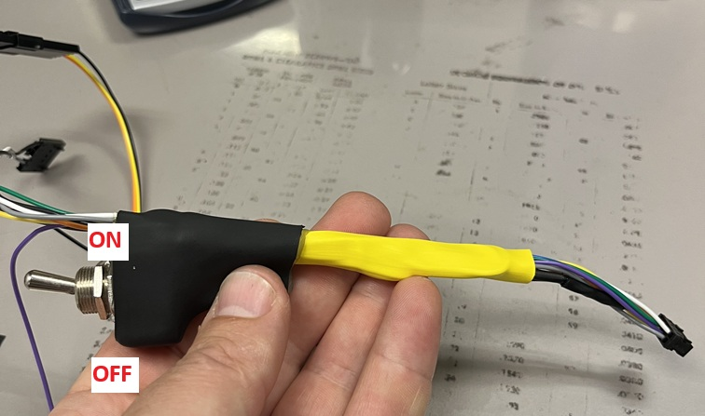
- Fold the longer power cable over 180 deg. and connect to the battery power connector (The system is now powered on).
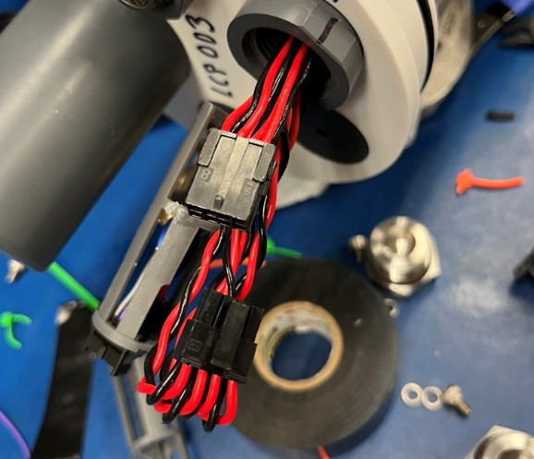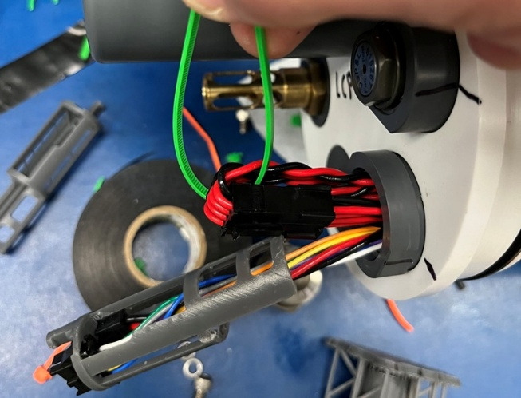

- Attach the other end of the coms cable to the usb to ttl circuit board using the orange-yellow-green-black wired connector and plug it into the laptop.
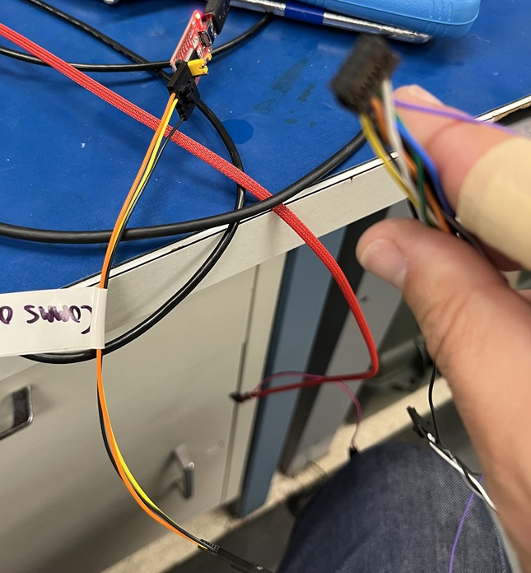
- Loop a green ziptie through the connected power cable loop and through the bottom of the cartridge. Secure so the ziptie lies as shown in the picture. Trim off the ziptie’s tail.
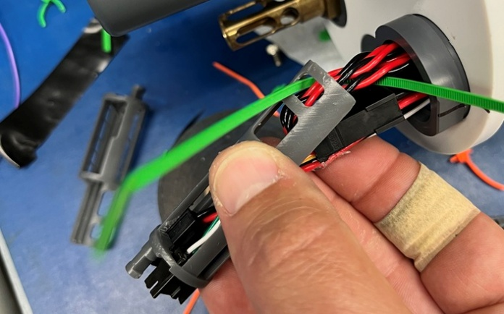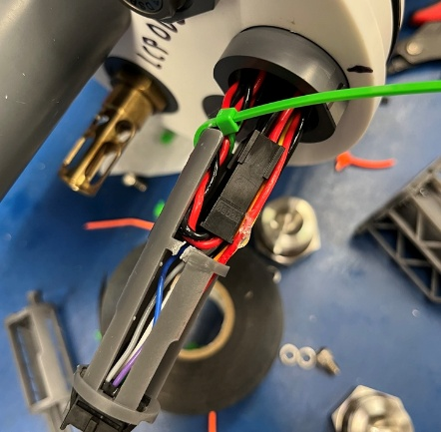
- Massage the wiring to lie as flat as possible and insert the entire cartridge assembly back into the port. You may have to wiggle it and massage it a bit to get it to fully insert.
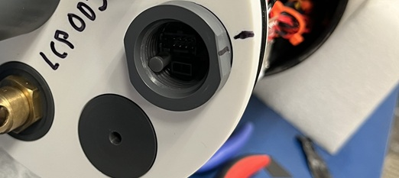
- Move the LCP to where it has a clear view of the sky for GPS acquisition.

- Open teraterm:
  - Set the terminal to send and receive “LF” only.
  - Set the baud rate to 921600
  - Enable the log
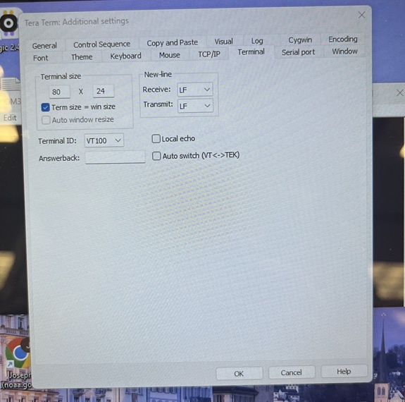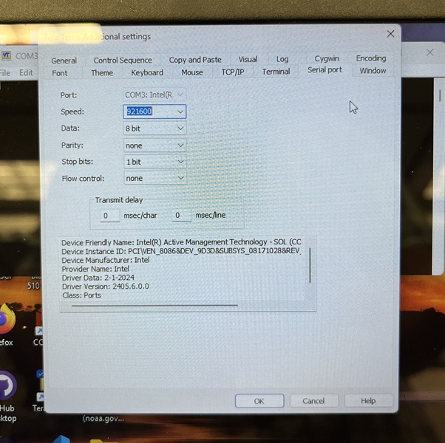
- Switch the reset switch to off, the program should now start, and the output should look like the attached file.
  - Compare the bolded output in the example file. Make sure that it is populated with real data.
  - Make sure it gets a GPS fix .
  - The piston should then move.
  - Make sure the LCP is in idle state (waiting for a 1.5m depth trigger to start profiling), you should see it printing out the pressure and time.
- If it looks good, disconnect the terminal cable and re-install the stainless steel port plug, being careful to use two wrenches to avoid twisting the wires.
- Your LCP is now ready to go into the water.

Firmware Flash (SHOULD NOT BE NEEDED)
- Open up the power and comms port per instructions under the Connect Battery Power section. Stop at step #8.
- Attach the other end of the coms cable to the usb to ttl circuit board to the white-grey-black wired connector (the piston board) and plug it into the laptop.
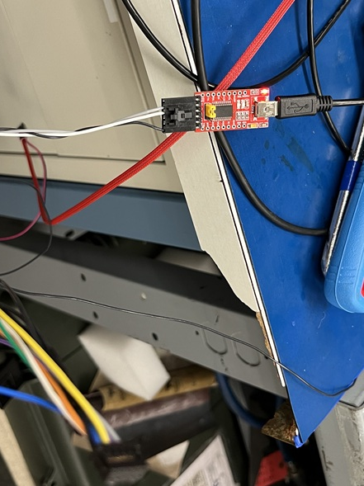
- Open teraterm:
  - set the terminal to send and receive “CR” only.
  - Set the baud rate to 115200
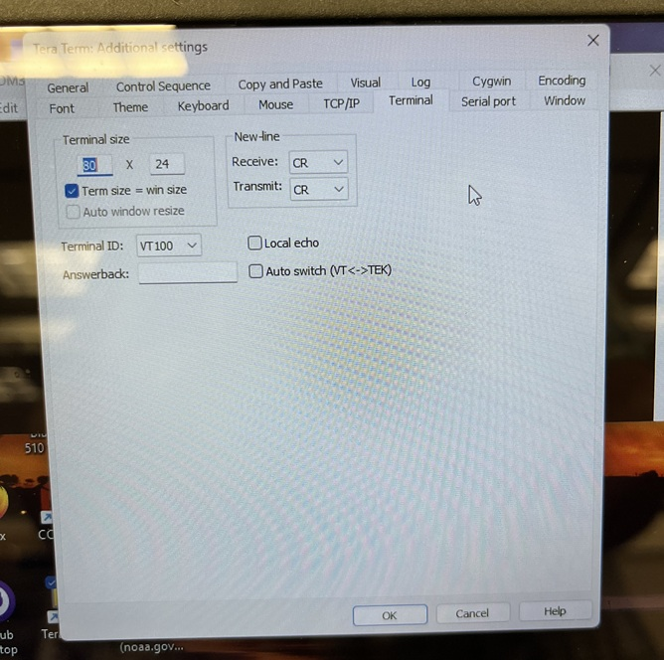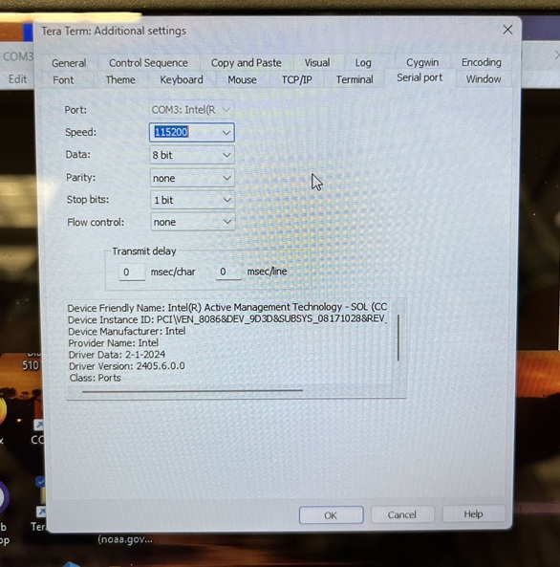
- Remove the 2 screws, and lock washers, holding the endcap onto the case.
- Hit enter in teraterm until you get the “shell>” prompt.
  - Type “fwd” then hit enter. The LCP should now open up. Let it open up fully. You may need to hold the case to get the endcap to open vs. just sliding on the big piston seal at the bottom end of the LCP.
- Open up visual studio code and make required edits to the config.h file located in the project directory C:\…\EDD-LCP_Control\Firmware\LCP_Control.
- Using windows explorer, delete the directory called “build” in the project directory above.
- Open up the windows command prompt and navigate to the project directory C:\…\EDD-LCP_Control\Firmware\LCP_Control.
- Create a new directory called “build” and change to that directory:
  - mkdir build
  - cd build
- In the ‘build’ directory, use CMake to get the project ready for building with the toolchain:
  - Type: cmake .. -DCMAKE_TOOLCHAIN_FILE=”../arm-gcc-toolchain.cmake” -G “Ninja”
- Connect the Jlink connector to the board.
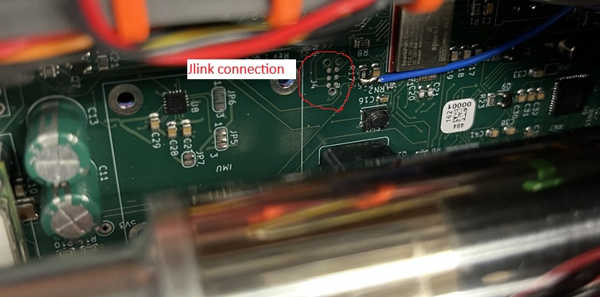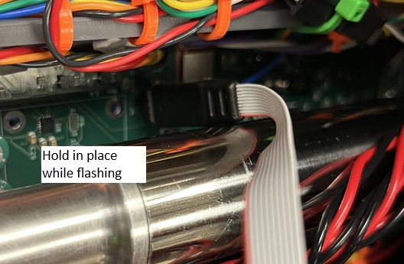
- Turn the coms cable reset switch to off.
- Use Ninja to build the project and flash it to the hardware:
  - Type: ninja flash_jlink
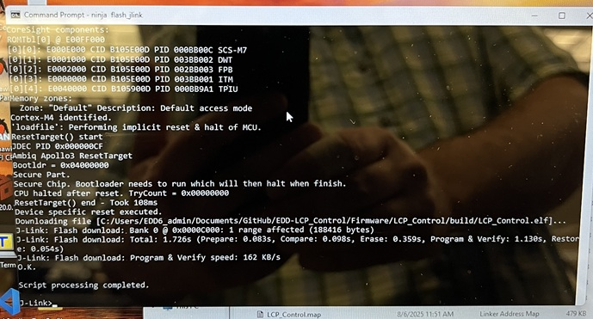
- After flashing, remove the jlink connector and keep the system powered on.
- Pull the outer LCP case away from the large piston at the bottom of the LCP (pull case towards the endcap) about 1 inch and make sure the 2 endcap attachment holes line up with the holes in the case. This will give you some time to correctly seat and align the endcap in the end of the case before the endcap is pulled into the case under tension (~400lb).
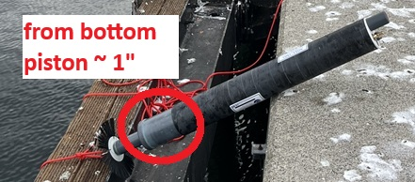
- Check the endcap oring and ID of the case to make sure it is clean and greased and verify that there are no wires that could be pinched when the endcap closes.
- Go back to Teraterm:
  - Type “rev” then hit enter. The LCP should now close.
  - Help the endcap seat properly into the case, it tends to want to hang on the lip.
- Once the LCP is fully closed, re-install the 2 screws holding the endcap onto the case.
- Resume the Connect Battery Power steps at step #9.

Example LCP Startup File

[2025-08-06 21:09:54.189] UART ENABLED
[2025-08-06 21:09:59.163] DATALOG_DEBUG is enabled
[2025-08-06 21:09:59.572]
[2025-08-06 21:09:59.572] Datalogger Qwiic Device Info
[2025-08-06 21:09:59.572] *******************************
[2025-08-06 21:09:59.572] Device Unique ID : 0x78
[2025-08-06 21:09:59.573] Device FW Version : 3.1
[2025-08-06 21:09:59.573] Device Status Info : SD init Good
[2025-08-06 21:10:00.083]
[2025-08-06 21:10:00.083] << LCP Log file LCP_LOG_0001.txt being created >>
[2025-08-06 21:10:00.131]
[2025-08-06 21:10:00.131] <<< TEST_BERINGSEA Profile selected >>>
[2025-08-06 21:10:00.132]
[2025-08-06 21:10:01.139]
[2025-08-06 21:10:01.139] *****************************
[2025-08-06 21:10:01.139] DEBUG :: LCP Controlboard
[2025-08-06 21:10:01.155] *****************************
[2025-08-06 21:10:01.180]
[2025-08-06 21:10:01.180]
[2025-08-06 21:10:01.180] LCP Profiler Information
[2025-08-06 21:10:01.180] **************************************
[2025-08-06 21:10:01.180] System ID : 77
[2025-08-06 21:10:01.196] LCP Firmware : 0.0.0-dev
[2025-08-06 21:10:01.196] Firmware Date : 8.6.25
[2025-08-06 21:10:01.212] Firmware Time : 11:51:28
[2025-08-06 21:10:01.212] LCP Variant : 0
[2025-08-06 21:10:01.228] LCP Serial : L00
[2025-08-06 21:10:01.228]
[2025-08-06 21:10:01.255] **************************************
[2025-08-06 21:10:01.256] LCP Physical parameters
[2025-08-06 21:10:01.256] **************************************
[2025-08-06 21:10:01.290] Estimated Mass : 11.139 kg, 24.557 lbs
[2025-08-06 21:10:01.290] Minimum Volume : 0.011 m³, 654.633 in³
[2025-08-06 21:10:01.290] Maximum Density : 1038.350 kg/m³, 0.038 lbs/in³
[2025-08-06 21:10:01.290]
[2025-08-06 21:10:01.306]
[2025-08-06 21:10:01.306] RTC Timer
[2025-08-06 21:10:01.306] ***************************************
[2025-08-06 21:10:01.322] Clock started on 08.06.2025 at 11:51:29 (local)
[2025-08-06 21:10:01.322]
[2025-08-06 21:10:02.345]
[2025-08-06 21:10:02.345] K9LX Pressure Sensor
[2025-08-06 21:10:02.345] **************************************
[2025-08-06 21:10:02.361] Firmware Ver : 5.20.12.28.
[2025-08-06 21:10:02.426] Serial Number : 217833
[2025-08-06 21:10:02.458] Pressure : 0.01673 bar
[2025-08-06 21:10:02.506] Temperature : 23.614 °C, 74.504 °F
[2025-08-06 21:10:02.522] Pressure : 1679 pascal
[2025-08-06 21:10:02.569] K9lx Pressure Sensor is initialized
[2025-08-06 21:10:02.570]
[2025-08-06 21:10:03.194] S9 : Sampling Stopped
[2025-08-06 21:10:03.386] S9 Temperature Sensor
[2025-08-06 21:10:03.401] **************************************
[2025-08-06 21:10:03.402] MID : T2UV
[2025-08-06 21:10:03.466] C0 : 0.0012662
[2025-08-06 21:10:03.466] C1 : 0.0002752
[2025-08-06 21:10:03.482] C2 : -0.0000007
[2025-08-06 21:10:03.482] C3 : 0.0000001
[2025-08-06 21:10:03.497] R0 : 3300.0
[2025-08-06 21:10:03.497] Average : 1
[2025-08-06 21:10:03.513] UID : 000000000302902CAF099D0358BF94F6
[2025-08-06 21:10:03.785] FW Ver : S9T0 V0.6
[2025-08-06 21:10:03.881] Status : OK
[2025-08-06 21:10:03.913] S9 Temperature Sensor is initialized
[2025-08-06 21:10:03.913]
[2025-08-06 21:10:05.749]
[2025-08-06 21:10:05.749] Piston Board Information
[2025-08-06 21:10:05.749] **************************************
[2025-08-06 21:10:05.766] System Identification : LCPPST01
[2025-08-06 21:10:06.118] Firmware build year : 2023
[2025-08-06 21:10:06.118] Firmware version : v0.1.0
[2025-08-06 21:10:06.118]
[2025-08-06 21:10:06.247] SENSORS :: Sensors are initialized
[2025-08-06 21:10:06.247]
[2025-08-06 21:10:06.247] STATE_initialize: Static Park and Profile data structures reset.
[2025-08-06 21:10:06.247] MEMORY INIT FLASH: Checking if flash region (first 256 bytes) is already erased...
[2025-08-06 21:10:06.247] MEMORY INIT FLASH: First 256 bytes appear erased. Skipping full region erase.
[2025-08-06 21:10:06.247] MEMORY INIT FLASH: Flash queue metadata reset and initialized for linear storage.
[2025-08-06 21:10:06.247] MEMORY: Static transmission queue initialized. Capacity: 58
[2025-08-06 21:10:06.247]
[2025-08-06 21:10:06.247] *****************************
[2025-08-06 21:10:06.247] FreeRTOS here
[2025-08-06 21:10:06.263] schedular is going to start
[2025-08-06 21:10:06.263] *****************************
[2025-08-06 21:10:06.263]
[2025-08-06 21:10:06.290] SPS :: Profile global event wait
[2025-08-06 21:10:06.291] PUS :: Popup global event wait
[2025-08-06 21:10:06.618] SENSORS :: GPS, Setting rate = 1Hz
[2025-08-06 21:10:06.618] SENSORS :: GPS, Task is starting...
[2025-08-06 21:10:06.618] SENSORS :: GPS, Setting period = 1000ms
[2025-08-06 21:10:06.633] SENSORS :: GPS, Timer has started for 3.0 Minutes
[2025-08-06 21:10:07.155] PDS :: systemcheck, GPS task->state = running
[2025-08-06 21:10:07.156] PDS :: systemcheck, GPS task->active : No fix
[2025-08-06 21:10:08.303] PDS :: systemcheck, GPS task->state = running
……………………………………………………………………………………………………………………………………………………………….
[2025-08-06 21:10:37.596] PDS :: systemcheck, GPS task->active : No fix
[2025-08-06 21:10:38.556] PDS :: systemcheck, GPS task->state = running
[2025-08-06 21:10:38.572] PDS :: systemcheck, GPS task->active : No fix
[2025-08-06 21:10:39.448] PDS :: systemcheck, GPS task->state = running
[2025-08-06 21:10:39.448] PDS :: systemcheck, GPS : fixed, latitude=47.6864815, longitude=-122.2544785, altitude=22.3579998
[2025-08-06 21:10:40.456] PDS :: systemcheck, GPS task->state = running
[2025-08-06 21:10:40.475] PDS :: systemcheck, GPS : fixed, latitude=47.6864815, longitude=-122.2544785, altitude=22.5000000
[2025-08-06 21:10:41.399] PDS :: systemcheck, GPS task->state = running
[2025-08-06 21:10:41.399] PDS :: systemcheck, GPS : fixed, latitude=47.6864777, longitude=-122.2544785, altitude=22.6229992
[2025-08-06 21:10:42.429] PDS :: systemcheck, GPS task->state = running
[2025-08-06 21:10:42.429] PDS :: systemcheck, GPS : fixed, latitude=47.6864777, longitude=-122.2544785, altitude=22.6389999
[2025-08-06 21:10:43.470] PDS :: systemcheck, GPS task->state = running
[2025-08-06 21:10:43.498] PDS :: systemcheck, GPS : fixed, latitude=47.6864777, longitude=-122.2544785, altitude=22.5470009
[2025-08-06 21:10:44.328] PDS :: systemcheck, GPS task->state = running
[2025-08-06 21:10:44.328] PDS :: systemcheck, GPS : fixed, latitude=47.6864738, longitude=-122.2544785, altitude=22.5200005
[2025-08-06 21:10:45.359] PDS :: systemcheck, GPS task->state = running
[2025-08-06 21:10:45.360] PDS :: systemcheck, GPS : fixed, latitude=47.6864700, longitude=-122.2544785, altitude=22.5529995
[2025-08-06 21:10:46.319] PDS :: systemcheck, GPS task->state = running
[2025-08-06 21:10:46.337] PDS :: systemcheck, GPS : fixed, latitude=47.6864662, longitude=-122.2544785, altitude=22.4319992
[2025-08-06 21:10:47.258] PDS :: systemcheck, GPS task->state = running
[2025-08-06 21:10:47.258] PDS :: systemcheck, GPS : fixed, latitude=47.6864624, longitude=-122.2544785, altitude=22.2399998
[2025-08-06 21:10:48.217] PDS :: systemcheck, GPS task->state = running
[2025-08-06 21:10:48.244] PDS :: systemcheck, GPS : fixed, latitude=47.6864586, longitude=-122.2544785, altitude=22.0949993
[2025-08-06 21:10:48.245] PDS :: systemcheck, RTC : <GPS Time Set>
[2025-08-06 21:10:48.642] SENSORS :: GPS Timer deleted successfully.
[2025-08-06 21:10:48.642] SENSORS :: GPS, Task is deleting...
[2025-08-06 21:10:49.146] PDS :: systemcheck, GPS task->state = running
[2025-08-06 21:10:49.146] PDS :: systemcheck, GPS : fixed, latitude=47.6864586, longitude=-122.2544785, altitude=22.0949993
[2025-08-06 21:10:50.106] PDS :: systemcheck, GPS task->state = not running
[2025-08-06 21:10:50.121] PDS :: systemcheck, GPS task->finished
[2025-08-06 21:10:50.314] file size = 214
[2025-08-06 21:10:50.314] Check : OK
[2025-08-06 21:10:50.410] Time : 21:10:06 (UTC)
[2025-08-06 21:10:50.586] Date : 08.06.2025
[2025-08-06 21:10:50.729] Latitude : 47.6864586
[2025-08-06 21:10:50.906] Longitude : -122.2544785
[2025-08-06 21:10:51.097] Altitude : 22.0949993
[2025-08-06 21:10:51.273]
[2025-08-06 21:10:51.273]
[2025-08-06 21:10:51.297] PDS :: systemcheck, RTC : TimeStamp, 08.06.2025, 21:10:07 (UTC)
[2025-08-06 21:10:51.298]
[2025-08-06 21:10:51.298] PDS :: systemcheck, FreeRTOS HEAP SIZE = 74000 Bytes
[2025-08-06 21:10:51.298]
[2025-08-06 21:10:51.313] PDS :: Transitionng to Idle State
[2025-08-06 21:10:52.289]
[2025-08-06 21:10:52.289] PDS :: Idle, piston move to park density=1037.0 kg/m³
[2025-08-06 21:10:52.329] LCP Volume to Length = 0.2135
[2025-08-06 21:10:52.329] PDS :: Idle, Setting -> density=1037.0 kg/m³, volume=655.482in³, length=0.2135in
[2025-08-06 21:10:52.329]
[2025-08-06 21:10:52.329] PISTON :: Setting rate = 1Hz
[2025-08-06 21:10:52.329] PISTON :: Volume, set-point = 655.4816
[2025-08-06 21:10:54.025] PISTON :: Volume = 0.0in³
[2025-08-06 21:10:57.335] PDS :: Idle, Piston task->state = running
[2025-08-06 21:10:57.335] PDS :: Idle, Piston task->active
[2025-08-06 21:10:58.325] PDS :: Idle, Piston task->state = running
[2025-08-06 21:10:58.325] PDS :: Idle, Piston task->active
[2025-08-06 21:10:59.014] PISTON :: Stall Count = 1
[2025-08-06 21:10:59.302] PDS :: Idle, Piston task->state = running
[2025-08-06 21:10:59.302] PDS :: Idle, Piston task->active
[2025-08-06 21:11:00.307] PDS :: Idle, Piston task->state = running
[2025-08-06 21:11:00.307] PDS :: Idle, Piston task->active
[2025-08-06 21:11:01.298] PDS :: Idle, Piston task->state = running
[2025-08-06 21:11:01.298] PDS :: Idle, Piston task->active
[2025-08-06 21:11:02.288] PDS :: Idle, Piston task->state = running
[2025-08-06 21:11:02.288] PDS :: Idle, Piston task->active
[2025-08-06 21:11:03.285] PDS :: Idle, Piston task->state = running
[2025-08-06 21:11:03.286] PDS :: Idle, Piston task->active
[2025-08-06 21:11:04.006] PISTON :: Stall Count = 2
[2025-08-06 21:11:04.277] PDS :: Idle, Piston task->state = running
[2025-08-06 21:11:04.277] PDS :: Idle, Piston task->active
[2025-08-06 21:11:05.265] PDS :: Idle, Piston task->state = running
[2025-08-06 21:11:05.265] PDS :: Idle, Piston task->active
[2025-08-06 21:11:06.256] PDS :: Idle, Piston task->state = running
[2025-08-06 21:11:06.257] PDS :: Idle, Piston task->active
[2025-08-06 21:11:07.245] PDS :: Idle, Piston task->state = running
[2025-08-06 21:11:07.246] PDS :: Idle, Piston task->active
[2025-08-06 21:11:08.236] PDS :: Idle, Piston task->state = running
[2025-08-06 21:11:08.236] PDS :: Idle, Piston task->active
………………………………………………………………………………………………………………………………………………………… [2025-08-06 21:13:03.711] PISTON :: Stall Count = 26
[2025-08-06 21:13:03.711] PDS :: Idle, Piston task->state = running
[2025-08-06 21:13:03.711] PDS :: Idle, Piston task->active
[2025-08-06 21:13:04.710] PDS :: Idle, Piston task->state = running
[2025-08-06 21:13:04.710] PDS :: Idle, Piston task->active
[2025-08-06 21:13:05.700] PDS :: Idle, Piston task->state = running
[2025-08-06 21:13:05.700] PDS :: Idle, Piston task->active
[2025-08-06 21:13:06.676] PDS :: Idle, Piston task->state = running
[2025-08-06 21:13:06.691] PDS :: Idle, Piston task->active
[2025-08-06 21:13:07.683] PDS :: Idle, Piston task->state = running
[2025-08-06 21:13:07.683] PDS :: Idle, Piston task->active
[2025-08-06 21:13:08.698] PISTON :: Stall Count = 27
[2025-08-06 21:13:08.698] PDS :: Idle, Piston task->state = running
[2025-08-06 21:13:08.698] PDS :: Idle, Piston task->active
[2025-08-06 21:13:09.696] PDS :: Idle, Piston task->state = running
[2025-08-06 21:13:09.696] PDS :: Idle, Piston task->active
[2025-08-06 21:13:10.686] PDS :: Idle, Piston task->state = running
[2025-08-06 21:13:10.686] PDS :: Idle, Piston task->active
[2025-08-06 21:13:11.674] PDS :: Idle, Piston task->state = running
[2025-08-06 21:13:11.674] PDS :: Idle, Piston task->active
[2025-08-06 21:13:12.664] PDS :: Idle, Piston task->state = running
[2025-08-06 21:13:12.664] PDS :: Idle, Piston task->active
[2025-08-06 21:13:13.685] PDS :: Idle, Piston task->state = running
[2025-08-06 21:13:13.685] PDS :: Idle, Piston task->active
[2025-08-06 21:13:13.877] PISTON :: Volume = 655.507in³
[2025-08-06 21:13:13.877] PISTON :: Volume reached
[2025-08-06 21:13:14.046] PISTON :: Volume updated = 655.507in³
[2025-08-06 21:13:14.046] PISTON :: SUCCESS. Volume = 655.507, diff = 0.025, max_diff = 0.040
[2025-08-06 21:13:14.094] PISTON :: task_move_piston_to_volume self-deleting...
[2025-08-06 21:13:14.685] PDS :: Idle, Piston task->state = not running
[2025-08-06 21:13:14.685] LCP Volume to Length = 0.2198
[2025-08-06 21:13:14.685] PDS :: Idle, density=1036.965 kg/m³, volume=655.507in³, length=0.2198in
[2025-08-06 21:13:14.685] PDS :: Idle, Piston task->finished
[2025-08-06 21:13:20.556] SENSORS :: Depth, Setting rate = 1.0Hz
[2025-08-06 21:13:20.571] MAX14830 :: gEventHandle, created
[2025-08-06 21:13:20.587] MAX14830 :: xSpiMutex, created
[2025-08-06 21:13:20.588] MAX14830 :: Power ON
[2025-08-06 21:13:20.603] SENSORS :: Depth, Setting period = 1000ms
[2025-08-06 21:13:20.635] PDS :: Idle, Pressure = 0.0170 bar
[2025-08-06 21:13:20.664] PDS :: Idle, Depth = 0.1677 m, rate = 0.1677m/1.0s
[2025-08-06 21:13:20.664] PDS :: Idle, Epoch = 1754514756
[2025-08-06 21:13:21.640] PDS :: Idle, Pressure = 0.0171 bar
[2025-08-06 21:13:21.640] PDS :: Idle, Depth = 0.1681 m, rate = 0.0003m/1.0s
[2025-08-06 21:13:21.640] PDS :: Idle, Epoch = 1754514757
[2025-08-06 21:13:22.617] PDS :: Idle, Pressure = 0.0171 bar
[2025-08-06 21:13:22.617] PDS :: Idle, Depth = 0.1680 m, rate = -0.0001m/1.0s
[2025-08-06 21:13:22.617] PDS :: Idle, Epoch = 1754514758
[2025-08-06 21:13:23.592] PDS :: Idle, Pressure = 0.0171 bar
[2025-08-06 21:13:23.592] PDS :: Idle, Depth = 0.1685 m, rate = 0.0005m/1.0s
[2025-08-06 21:13:23.592] PDS :: Idle, Epoch = 1754514759
[2025-08-06 21:13:24.569] PDS :: Idle, Pressure = 0.0170 bar
[2025-08-06 21:13:24.570] PDS :: Idle, Depth = 0.1678 m, rate = -0.0007m/1.0s
[2025-08-06 21:13:24.570] PDS :: Idle, Epoch = 1754514760
[2025-08-06 21:13:25.546] PDS :: Idle, Pressure = 0.0170 bar
[2025-08-06 21:13:25.546] PDS :: Idle, Depth = 0.1669 m, rate = -0.0009m/1.0s
[2025-08-06 21:13:25.546] PDS :: Idle, Epoch = 1754514761
[2025-08-06 21:13:26.523] PDS :: Idle, Pressure = 0.0172 bar
[2025-08-06 21:13:26.523] PDS :: Idle, Depth = 0.1690 m, rate = 0.0021m/1.0s
[2025-08-06 21:13:26.523] PDS :: Idle, Epoch = 1754514762
[2025-08-06 21:13:27.498] PDS :: Idle, Pressure = 0.0169 bar
[2025-08-06 21:13:27.498] PDS :: Idle, Depth = 0.1662 m, rate = -0.0027m/1.0s
[2025-08-06 21:13:27.498] PDS :: Idle, Epoch = 1754514763
[2025-08-06 21:13:28.476] PDS :: Idle, Pressure = 0.0171 bar
[2025-08-06 21:13:28.476] PDS :: Idle, Depth = 0.1687 m, rate = 0.0025m/1.0s
[2025-08-06 21:13:28.476] PDS :: Idle, Epoch = 1754514764
[2025-08-06 21:13:29.451] PDS :: Idle, Pressure = 0.0171 bar
[2025-08-06 21:13:29.451] PDS :: Idle, Depth = 0.1686 m, rate = -0.0001m/1.0s
[2025-08-06 21:13:29.451] PDS :: Idle, Epoch = 1754514765
[2025-08-06 21:13:30.429] PDS :: Idle, Pressure = 0.0169 bar
[2025-08-06 21:13:30.429] PDS :: Idle, Depth = 0.1668 m, rate = -0.0018m/1.0s
[2025-08-06 21:13:30.429] PDS :: Idle, Epoch = 1754514766
[2025-08-06 21:13:31.406] PDS :: Idle, Pressure = 0.0171 bar

